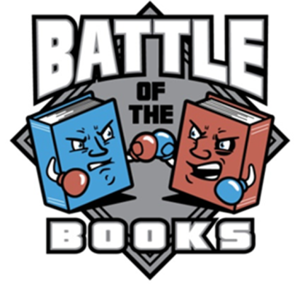
CCSD “Battle of the Books”

Do you LOVE Reading?
Do you remember little details from the books you have read?
Do you like to play games?
Do you like being part of a team?
Then B.O.B is for you!

HERE IS HOW IT WORKS…
This club is open to all fourth & fifth grade students. It is a team event with each team consisting of four members only. Your team must read the 8 designated books listed below between SEPTEMBER & MARCH (7 months). All of the books are in the School Library, County Libraries or they can be purchased on your own. We will hold Jeopardy-Style Battles for points in the Spring. After two rounds, the 4 teams with the highest combined points will move to the semi-final round. The two winning teams will advance to the FINAL BATTLE!!!!

DATES YOU SHOULD KNOW…
Team Entrance Deadline Friday, Sept 6, 2019
Open LIBRARY Begins Wednesday, Sept 11 @ 8:30am
Preliminary/Semi-Final Battles MARCH or APRIL 2020
Final School Battle Assembly (3-5th grade is invited to watch) MARCH OR APRIL 2020
OPEN LIBRARY EVERY WEDNESDAY 8:30AM

Regional School Battles: (school winning team only) Location TBA, Friday, April ? 5pm (Check-in by 4:30 pm)
District Finals: Regional Winners will compete at the Whitney Public Library, Date TBA
(all B.O.B. participants invited to attend & watch)
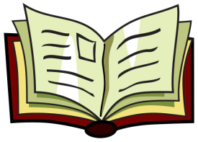
HERE ARE THE BOOKS YOU WILL BE READING…

Bob by Wendy Mass and Rebecca Stead
Bravelands #1 Broken Pride by Erin Hunter
A Dog Like Daisy by Kristin O'Donnell Tubb
The Dragon With a Chocolate Heart by Stephanie Burgis
The Great Shelby Holmes by Elizabeth Eulberg
Word of Mouse by James Patterson and Chris Grabenstein
Merci Suarez Changes Gears by Meg Medina
The Girl Who Drew Butterflies: How Maria Merian’s Art Changed Science by Joyce

Registration/Permission

Yes, I want to participate in the Battle of the Books!

Your Name: Grade: Teacher:

The following people have agreed to be my Battlemates:
#1: Grade: Teacher:
#2: Grade: Teacher:
CREATE A
STRONG TEAM
#3: Grade: Teacher:

Our Team Name will be:

The Team Captain is:

*EVERY team member needs to turn in paperwork*

By signing below, I agree to allow my child, , to participate in Battle of the Books in which there is a $15 fee to participate. This fee will help to cover books, shirts, & prizes. I understand that the school rounds are tentatively set for the end of March or early April 2020 & my child needs to have books read by then. I also understand that if my child is on the winning team, the multi-school battle will be held in April. Mrs. Wilson, Mrs. Huskey & Ms. Parrish will be available in the library EVERY WEDNESDAY morning to meet with teams beginning in Sept! It is optional to attend but meeting with your team & strategizing is highly recommended. If you have any questions regarding this club, please contact Ms. Parrish, School Counselor @ parrik@nv.ccsd.net.
Parent’s Name: Phone Number:
Parent’s E-Mail(write neatly):
Parent’s Signature:

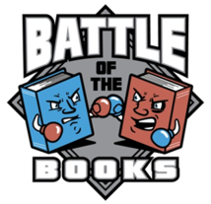
Please return this form to Ms. Parrish on or before Friday, Sept. 6
Rules

FORMULATING THE TEAM…
- Teams can have only 4 battlemates & decide a team name.
- One person will be elected to be the Team Battle Captain.

READING THE BOOKS…
- A list of the required reading has been distributed. The team will be required to read all of the 8 books or they can divide the books up. Teams will be quizzed on ALL 8 books. Again, teams can choose to have each battlemate read all of the books or assign certain books to certain battlemates. If you choose to assign books, then each person should know their books VERY well!
- Concentrate on the small details of the books.
- Take notes while you are reading that which you find interesting. You will be given a highlighter, a notebook, & sticky notes for this.

HOW THE BATTLES WILL RUN…
- The battles will be on a Jeopardy-Style Board although you will not need to phrase your answer in question format. For Example: You might say…
We will take Authors and Illustrators for 10 points.
Question: “Who is the Author of Charlie and the Chocolate Factory”?
Answer: Roald Dahl
- You will not have to buzz in your answer. Each team will take a turn choosing & answering their question.
- The team that goes first will be determined by coin flip.
- You will have 30 seconds after the question to answer.
- Only the Team Captain can give the Team’s answer.
- You will not be allowed to have any study materials on the table. You will be allowed a blank piece of paper to write notes to the Team Captain.
- If you do not answer your question correctly within the 30 seconds, the other team has a chance to steal the points. They will have 10 seconds in which to answer. Whether they get the question correct or not, they will then take their turn.
- When all of the questions have been answered, the team with the highest number of points will be declared the winner.
- If the round ends in a tie, a tie breaker question will determine the winner. No points are awarded for tie breaker questions.

HOW THE TEAMS ARE ELIMINATED…
- We will hold preliminary rounds called mini-battles & your scores from these rounds will be added together.
- Teams are chosen randomly by pulling names out of a hat. However, you cannot play the same team in both mini-battles.
- The top 4 teams will advance to the Semi-Final Battle.
- The winners of the Semi-Final Battle will advance to the Final Battle.
- The team that wins the Final Battle will be declared the winner MAY’S Battle of the Books & will move on the district’s Regionals!
Happy Reading Marshals!

